CptS 443/543—Human-Computer Interaction

Jinyang Ruan

011696096

Individual Assignment 4

**Smart Home Manager Design:**

**Home Page:**

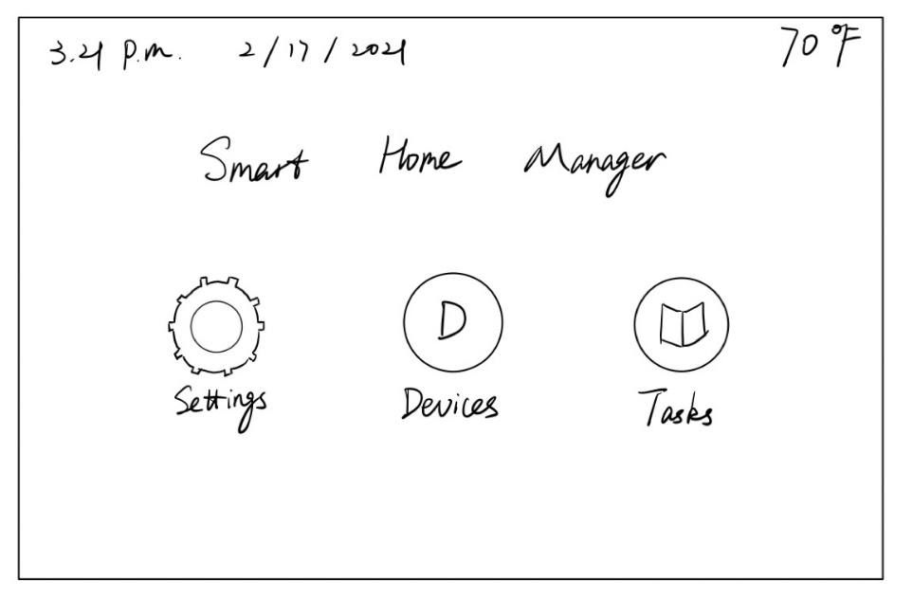

Figure 1.

As long as user touch the screen, the screen will turn on and show this home page. Users then can select “Settings”, “Devices”, and “Task” for further actions.

**Settings Page:**

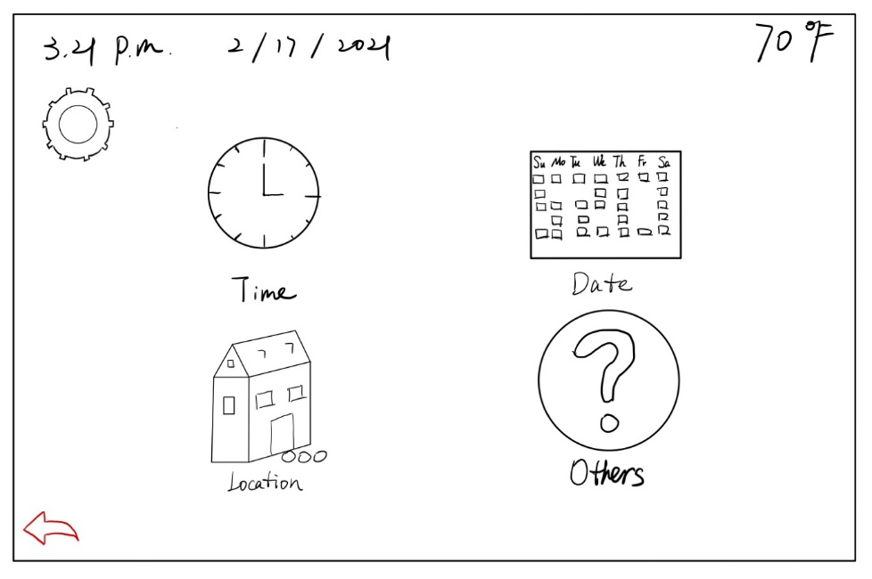

Figure 2.

After user pressed “Settings” icon, above screen will be shown. User can select “Time”, “Date”, “Location”,and “Others” for further settings. (requirement 1)

**Example--Time Setting:**

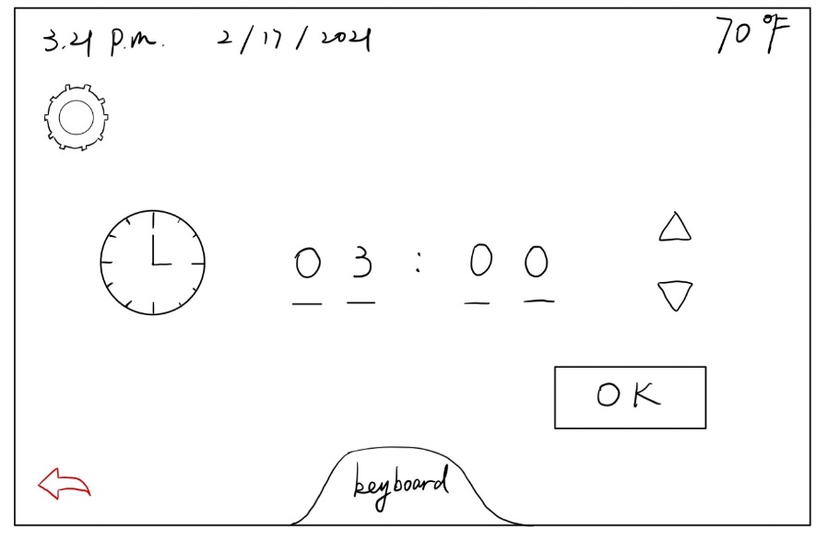

Figure 3.

For example, if user press “Time” icon, he/she will be able to set time. User can also press red arrow icon for going back last page. If user wants to go back to home page, he/she is supposed to press the icon on the top left corner of the screen.

**Other device settings:**

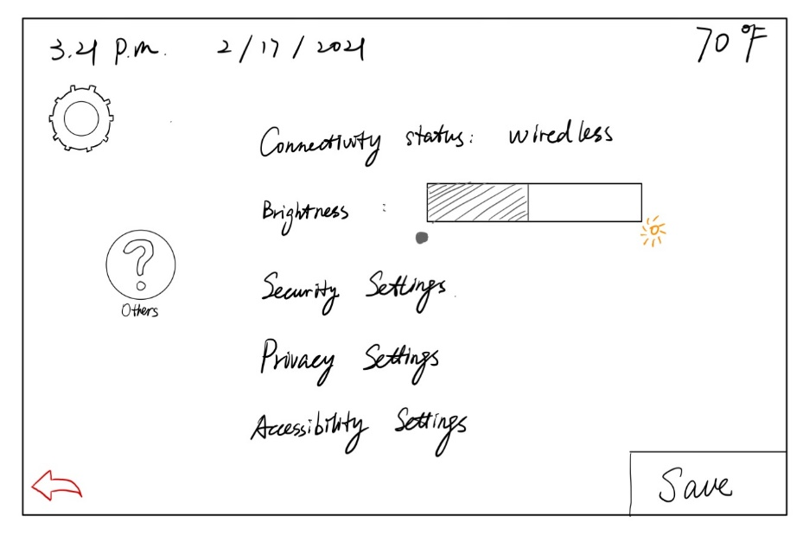

Figure 4.

Users can press ”Others” icon 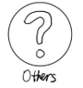 on “Settings page” for further settings, for example, device network connectivity, brightness settings, security, privacy, accessibility settings,etc. (requirement 2) User can also press red arrow icon for going back last page. If user wants to go back to home page, he/she is supposed to press the icon on the top left corner of the screen.

**Devices Connection States Shown/Control Page:**

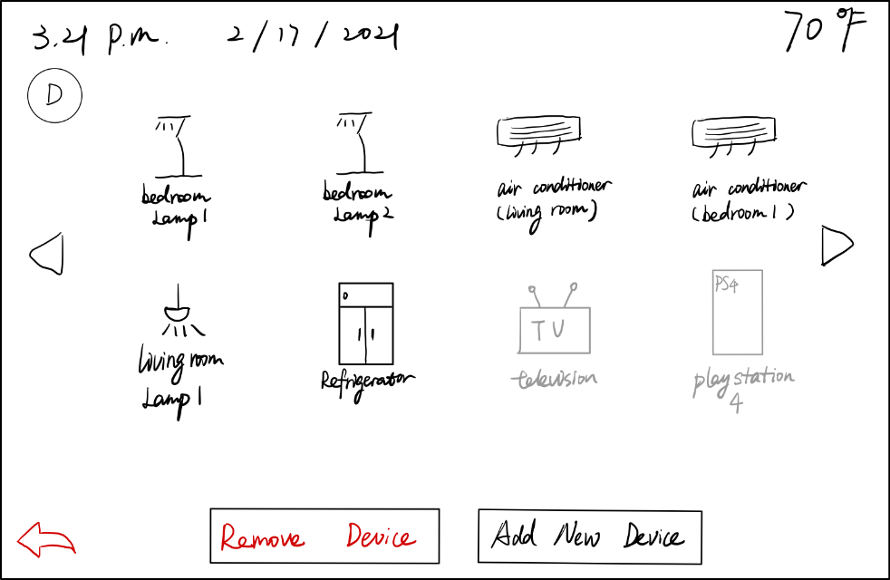

Figure 5.

User can press “Devices” icon on home page for further actions. Above figure will be shown after user pressed “Devices”, all connected smart devices will be shown on this screen as solid black. All disconnected devices will be shown as light grey color. User can press light grey icons for connection. (requirement 4) Also, user can press “Remove Device” then select the target devices’ icon for disconnecting devices, and press “Add New Device” for adding new devices. System will search devices that are able to connect and then user can add target new devices. (requirement 3)

**Manually Control Devices Page—Example 1:**

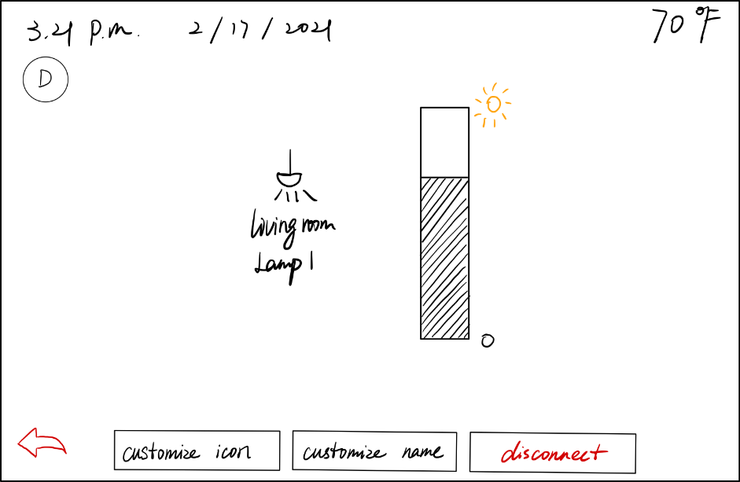

Figure 6.

Users can select connected devices on previous page for devices settings. (requirement 5)For example, if user press “living room lamp 1” for setting, above figure 6 will be shown. User can customize icon, customize device name, and disconnect the device.

**Manually Control Devices Page—Example 2:**

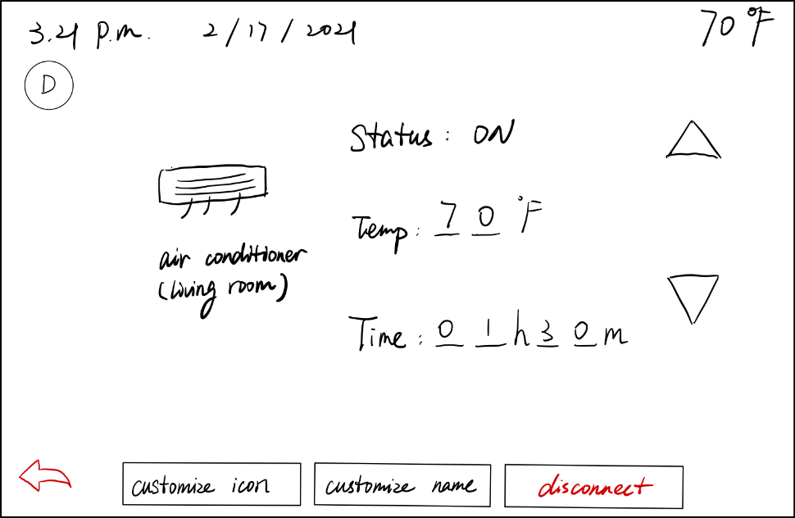

Figure 7.

If user press “air conditioner (living room)” icon, the above figure 7 will be shown. User can change the status of the air conditioner, set the temperature, and set timing. Also, user can customize icon, customize device name, and disconnect the device. User can also press red arrow icon for going back last page. If user wants to go back to home page, he/she is supposed to press the icon on top left corner of the screen.

**Tasks Page:**

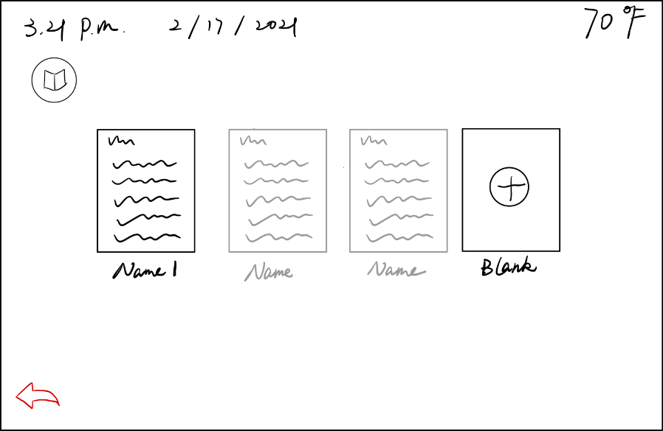

Figure 8.

User can press “Tasks” icon to this page. On “Tasks” page, the first solid black icon represents the current running task, the following light grey icon represent the previous saved tasks. Users can press the grey icon for implement and press the last “Blank” page for creating a new task. (requirement 6)

**Task States Page:**

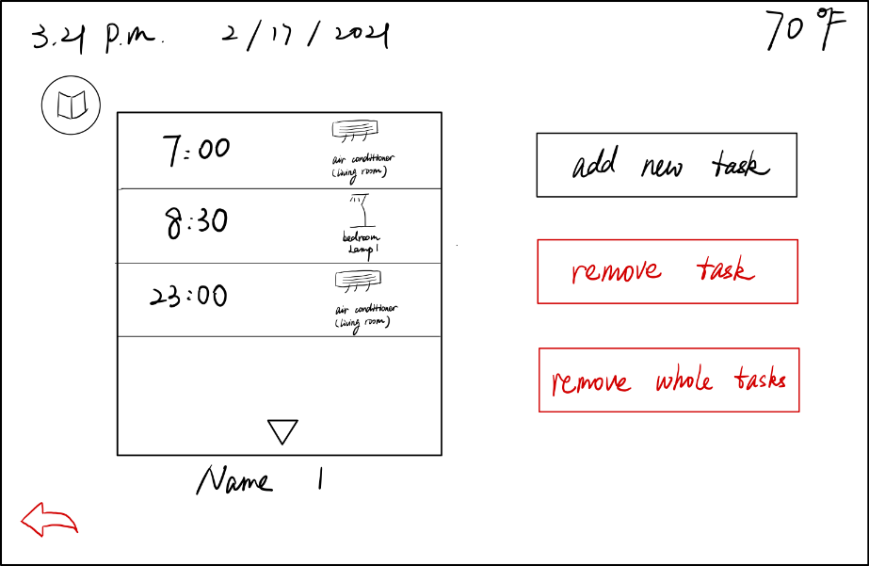

Figure 9.

After user selected one task, above page will be shown. Left side shows the current saved tasks. On this screen, it only shows the task time and the device. User can check and modify each task by pressing it. (requirement 6) User also can add new task, remove current task, and delete the whole tasks through right hand side icons. User can also press red arrow icon for going back last page. If user wants to go back to home page, he/she is supposed to press the icon on the top left corner of the screen.

**Task Modify Page:**

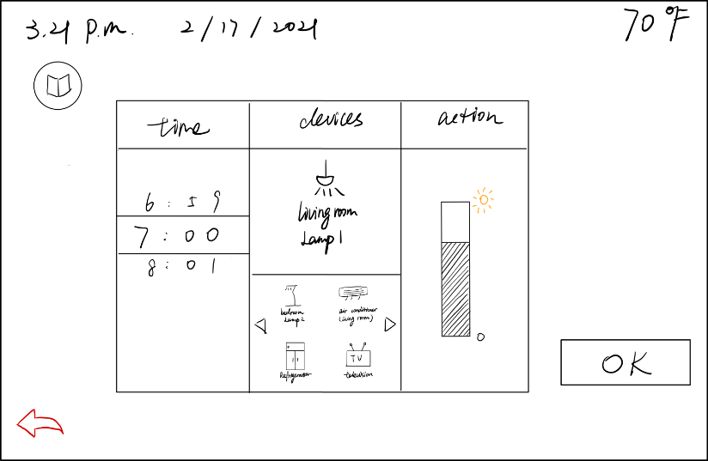

Figure 10.

After user click “add new task” or one saved task, task modify page will show up. User can set task time, execution device, and action details. All connected devices will be shown under “devices”. Once choosing one execution device, the action details on the right will change. After all settings down, press “OK” for saving, then automatically go back to last “Task Status” page. (requirement 6)

**Analysis:**

1. **Avoid ambiguity in information displays.**

* All signifiers are clear. Icons are easy to be read. User can almost fully understand icons without signifiers. For example, nut icon is used for representing “settings”, back arrow is used for going back last page. Users will interpret information displays uniformly.

1. **Make sure colors are distinguishable, even for colorblind.**

I use red color for removing or disconnecting actions, in order to remind users that their actions may be irreversible. Compared to the black theme, red is obvious and distinguishable. For example, in figure 5, red button is very obvious. In addition, I use solid black and light grey to distinguish connected status and disconnected status, it is very easy to distinguish even for colorblind since it is nothing about the different colors, it is about the intensity of colors.

1. **Be consistent.**

Some icons that are used in different pages, they have same functions. For example, the red arrow exists in all pages but home page, it is used to return to the previous page all the time. Some icons are created for going back to home page directly, they are “settings”,”devices”, and “tasks”. Although icons are different, but they are at the same location when they are used to go back to home page.

1. **Minimize text in interfaces.**

I seldom use text in interfaces. For example, when user wants to change the brightness of the lights, there is no text around this figure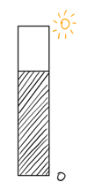, but user still can understand up means brighter and going down means dimmer. Also, users can customize name of devices and tasks to minimize text.

1. **Signifiers**

Although users can understand some functions through icons, I still add signifiers for clarification. For example, on the home page, I add “Settings”, “Devices”, and “Tasks” under three icons to ensure users understand the three main functions of this smart home manager.

1. **Natural mapping**

All arrows in interfaces match the natural mapping. For example, in figure 5, up arrow is used to set temperature higher and down arrow is used to set temperature lower.

1. **Feedback**

As long as users press icons or buttons, the screen will move to next page or give feedbacks for further actions. For example, once user press one of the icons on home page (Figure 1), the screen will move to next pages (Figure 2, Figure 5, and Figure 8).